 Classification vs Clustering

Last Updated: 03-10-2019

**Prerequisite:**[Classification](https://www.geeksforgeeks.org/getting-started-with-classification/) and [Clustering](https://www.geeksforgeeks.org/clustering-in-machine-learning/)

As you have read the articles about classification and clustering, here is the difference between them.

Both Classification and Clustering is used for the categorisation of objects into one or more classes based on the features. They appear to be a similar process as the basic difference is minute. In the case of Classification, there are predefined labels assigned to each input instances according to their properties whereas in clustering those labels are missing.

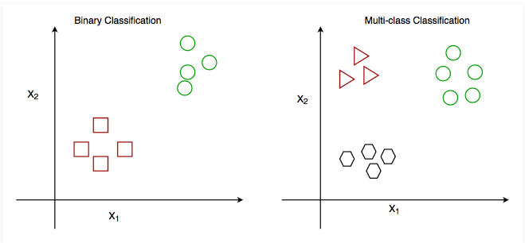

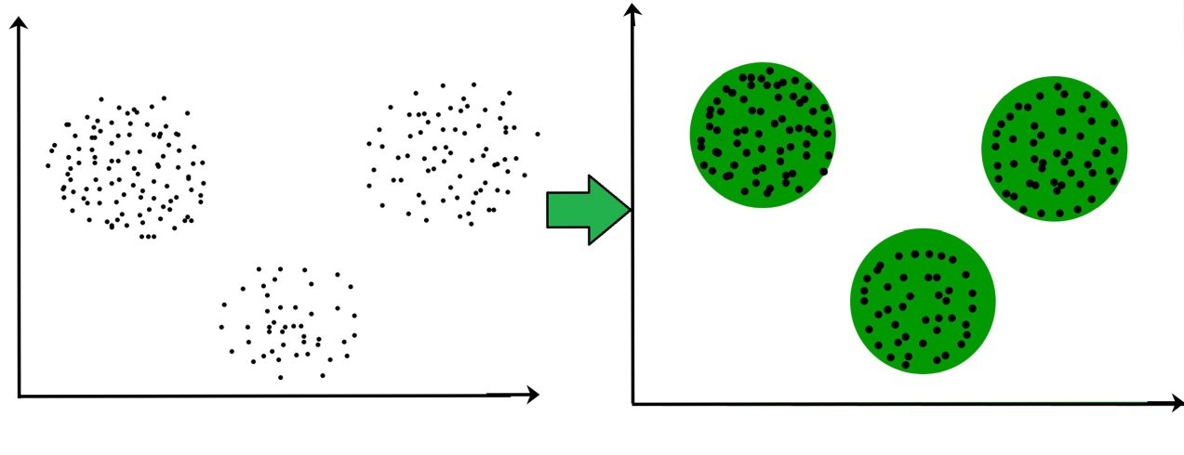

**Comparison between Classification and Clustering:**

| **PARAMENTER** | **CLASSIFICATION** | **CLUSTERING** |
| --- | --- | --- |
| Type | used for supervised learning | used for unsupervised learning |
| Basic | process of classifying the input instances based on their corresponding class labels | grouping the instances based on their similarity without the help of class labels |
| Need | it has labels so there is need of training and testing dataset for verifying the model created | there is no need of training and testing dataset |
| Complexity | more complex as compared to clustering | less complex as compared to classification |
| Example Algorithms | Logistic regression, Naive Bayes classifier, Support vector machines etc. | k-means clustering algorithm, Fuzzy c-means clustering algorithm, Gaussian (EM) clustering algorithm etc. |

**Differences between Classification and Clustering**

1. Classification is used for supervised learning whereas clustering is used for unsupervised learning.
2. The process of classifying the input instances based on their corresponding class labels is known as classification whereas grouping the instances based on their similarity without the help of class labels is known as clustering.
3. As Classification have labels so there is need of training and testing dataset for verifying the model created but there is no need for training and testing dataset in clustering.
4. Classification is more complex as compared to clustering as there are many levels in classification phase whereas only grouping is done in clustering.
5. Classification examples are Logistic regression, Naive Bayes classifier, Support vector machines etc. Whereas clustering examples are k-means clustering algorithm, Fuzzy c-means clustering algorithm, Gaussian (EM) clustering algorithm etc.

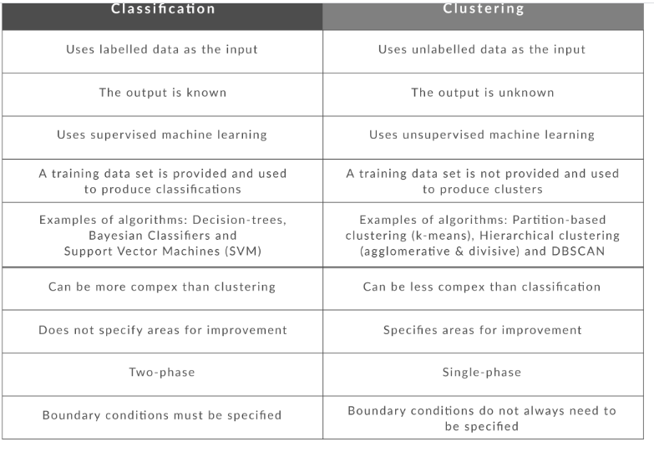

https://www.infoworld.com/article/3252088/how-classification-and-clustering-work-the-easy-way.html